**The Battle of Neighborhoods (Week 1) - PVR – Burger Shop - Anil Singh**

# ****Data**** section:

To start with we have used data Wikipedia page “PVR Cinemas” and only considered Mumbai locations movie theatres.

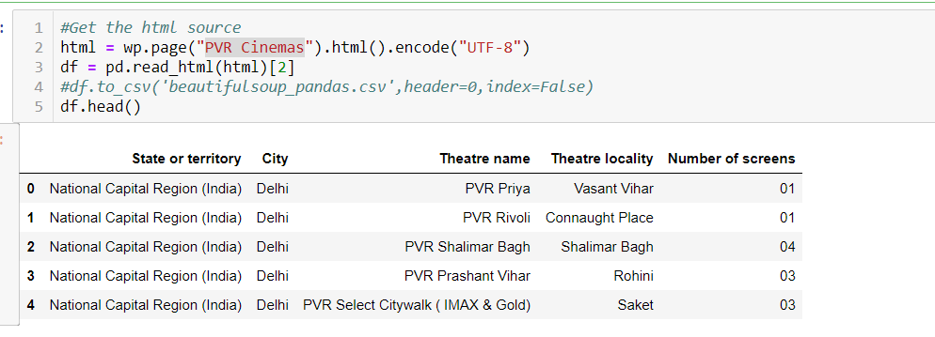

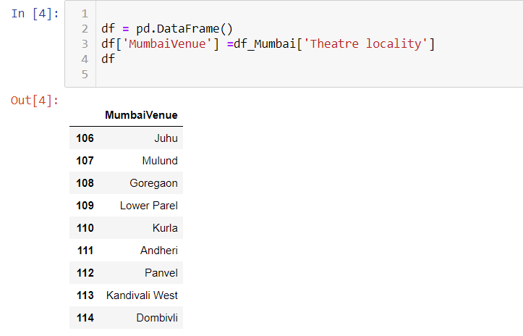

Capture the geo location for PVR Mumbai theatres using <http://nominatim.openstreetmap.org>.

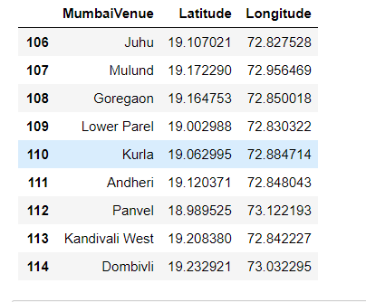

Started study for Venues nearby locality office location, Burger Joints, Other movie theatres, Nearby college university to find the cost effective location for opening Burger Shop. Using Foursquare API.

